**ACKNOWLEDGEMENT**

We would like to take this opportunity to thank all the people who helped in making our project “**Bridge Safety using microcontoller”** successful and a reality.

First, we would like to thank our respected principal, Dr.R.S.Deshpande, for his continuous encouragement.

We express our deep sense of gratitude to our mentor, HOD Mrs.S.M. Walke for the adroit guidance, constructive suggestions, critical evaluation and perceptual encouragement during the conduct of investigation and the preparation of manuscript. We shall remain grateful to her for the same forever.

We would like to thank Ms.S.M.Walke, Head of the department (E&TC), for her guidance, profound interest and perceptual encouragement in the completion of this project.

We would like to thank our college staff members, for providing the necessary facilities for completing the project. All have been very helpful and kind. Last but not least, a vote of thanks to all our colleagues, who have supported us all time and boosted in doing the project report.

**ShindeAparna S.**

**Thokal Priyanka P.**

**ThoratAarti S.**

**INDEX**

|  |  |  |
| --- | --- | --- |
| SR.NO. | Contents | Page No. |
| 1. | Chapter -1 Abstract |  |
| 2. | Chapter-2 Introduction |  |
| 3. | Chapter-3 Literature survey. |  |
| 4. | Chapter-4 System Modelling  4.1 Block Diagram  4.2 Block Diagram Desciption  4.3 PIC 16F877 Microcontroller  4.4LCD  4.5 GSM |  |
| 5. | Chapter-5 Project Flow  Hardware Designing Aspects:  5.1 Power Supply  5.2 Rectifier unit  5.3 Filter circuit  5.4 Circuit Diagram  5.5 Power Supply Designing  5.6 PCB Designing  5.7 PCB Layout  5.8 Artwork |  |
| 6. | Chapter-6 Software used  6.1 Algorithm  6.2 Flowchart  6.3 Software Code |  |
| 7. | Chapter-7 Performance Evaluation |  |
| 8. | Chapter-8 Conclusion  8.1 Advantages  8.2 Application  8.3 Conclusion  8.4 Future Scope  8.5 References |  |
| 9. | Chapter-9 Project Photo |  |
| 10. | Chapter-10 Data Sheet |  |

**List of Figure:**

|  |  |
| --- | --- |
| Figure.no. 4.1 | Block Diagram |
| Figure.no.4.2 | Pin diagram of pic 16F877 |
| Figure.no.4.3 | LCD Display |
| Figure.no.5.1 | Power Supply |
| Figure.no.5.2 | Circuit Diagram |
| Figure.no.6.1 | Flowchart |

**Chapter**-**1**

**ABSTRACT**

Advancement in sensor technology have brought automated real time bridge health monitoring system. Many long span bridges in Korea and in japan have adopted this real time health monitoring system. however the current system uses complicated and high cost wired network amongst sensors in the bridge and high cost optical cables between the bridge and the management center ,Which inceases overall cost of installation and maintainance cost of health monitoring system.

Acrosses the country thousands of bridges have rich the end of their useful lifespam and are in need of replacement. many of this structures support a significant volume of commercial vehicles, creating vital economic links across the nation . There are quite a few bridges that get a D grade" for maintenance and safety, Sensor technology can make a big safety difference by giving a bridge a "physical" and then monitoring its health. In addition, we will experiment with a sensor made of wire that can be applied to the surface of bridges to detect corrosion and cracks. Since carbon wire conduct electricity by sending a current through the bridge, it is possible to detect structural weakness through changes in the electrical properties.

**Chapter-2**

**INTRODUCTION**

As we know recently happened accident of savitri bridge ,from that we got an idea to design a project based on bridge safety. It will maintain the safety of bridge and avoids the major accident. In this project we mainly use sensors which will sense the vibration,crack or condition of that bridge.The sensory input are process to represent the condition of bridge .sensor technology have made the monitoring process more accurate and fast.

GSM technology is suggested to send the data to the remote location in which the maintenance office is loaded. This system include the GSM module for long and short distance wireless data communication which is mobile phone carrier network. This sytem uses 4 sensors and interface LED for displaying output of all sensors. The sensing capabilities of these nodes satisfies the immediate requirements for economic, low-maintenance load ratings and short-term dynamic measurements in addition to providing the hardware functionality for development of a long-term continuous bridge monitoring system.

Bridges are continuously subjected to destructive effects of material aging, widespread corrosion of steel reinforcing bars in concrete structures, corrosion of steel structures and components, increasing traffic volume and overloading, or simply overall deterioration and aging. These factors, combined with defects of design and construction and accidental damage, prompt the deterioration of bridges and result in the loss of load carrying capacity of bridges. The condition of heavily used urban bridges is even worse: one in three are classified as aging or unable to accommodate modern vehicle weights and traffic volume. Therefore, a significant number of these structures need strengthening, rehabilitation, or replacement, but public funds are not generally available for the required replacement of existing structures or construction of new ones.

A bridge is a structure built to span road , river , body of water or any other physical obstacle design of bridges will vary depending upon the function of bridge & nature of the area where the bridge is to be constructed. The first bridges were made by nature it self as simple as log fallen across a stream or stones in the river. The first bridges made by humans were probably spans of cut wooden logs or planks and eventually stones. Using a simple support& cross beam arrangement Some early American use trees or bamboo poles to cross small caverns or wells to get form one place to another.

Safety is top priority with everyone involved in the road and bridge building market.A safety channel is reflection of commitment to reduce injuries and fatalities at the jobsite.Bridge safety depends upon understanding the risk they pose or can suffer from the correct choice of materials,designs that takes amount of wind, floods or earthquakes and regular inspection of the bridges integrity all play vital parts.

**Chapter-3**

**LITERATURE SERVEY**

**Literature servey:**

The first bridges were made by nature itself as simple as log fallen across a stream or stones in the river. The first bridges made by humans were probably spans of cut wooden logs or planks and eventually stones. As per with the help of the wireless technology many problems due to data cables and expensive optical cable are now minimized and eliminated.

Throughout the history of bridges,their tendency to vibrate under different dyanamic loading such as wind,earthquake and traffic load has been a matter of concern.several investigation have been taking place in recent years to determine the vibration properties of bridges. In 2001 there are several studies on the dynamic analysis of moving vehicles on bridges. Based on the review,important parameters affecting the dynamic vehicle-bridge interaction due to moving vehicle identified including the natural frequencies of the bridge, number of vehicles,surface roughness and damping of the bridge and vehicle.

As we know about the recently occurred accident of savitri bridge ,from that we got an idea to design a project based on bridge safety. It will maintain the safety of bridge and avoids the major accident. In this project we mainly use sensors which will sense the vibration, crack or condition of that bridge. This system include the GSM module for long and short distance wireless data communication which is mobile phone carrier network.

**CHAPTER 4**

**SYSTEM MODELLING**

**4.1Block Diagram**

**Bridge**

Vibration sensor

Conductive probe as sensor

Switching CKT0-24Vdc

Microcontroller 16f877

24Vdc SMPS

PC for ladder download

Relay Driver

Relay Bank

Red/Green Signal

Bridge Gate Motor

Audio Hooter

**Road**

Road

Fig.4.1. Block Diagram

* 1. **BLOCK DIAGRAM EXPLANATION**

The above block diagram shows the bridge safety & security system. The project bridge safety system using microcontroller is divided into different hardware ports.

* The input sensor.
* Microcontroller and its accessories
* LCD display
* Relay driver & keypad
* GSM Communication
* Bridge signal, Hooter and Traffic signal
* Power supply

**Input sensor:**

Two types of sensor are used. The conductive wire rope and the tilt sensor. These sensor provide the different signals to the microcontroller.

**4.3Microcontroller (PIC16F877):**

It is the main central processing unit embedded C. The input output port used for different purposes. The working frequency is 20 MHz. At the output serial communication interfaces is provided. This controller is microchip.

**Features:**

**PIC16F877:**

* RISC architecture
  + Only 35 instructions to learn
  + All single-cycle instructions except branches
* Operating frequency 0-20 MHz
* Precision internal oscillator
  + Factory calibrated
  + Software selectable frequency range of 8MHz to 31KHz
* Power supply voltage 2.0-5.5V
  + Consumption: 220uA (2.0V, 4MHz), 11uA (2.0 V, 32 KHz) 50nA (stand-by mode)
* Power-Saving Sleep Mode

**PIN DIAGRAM**

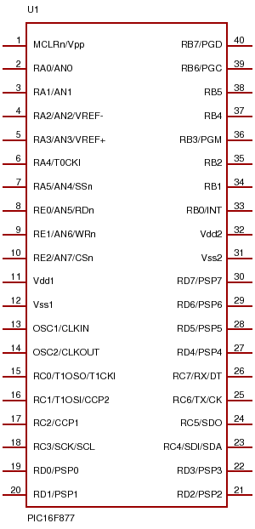

P

I

C

1

6

F

8

7

7

Fig .4.2 pin diagram of pic 16F877

**4.4 LCD Display:**

This display is 16*2 alpha numeric type. We can write the alphabets as well as numerical on this display. The control lines are interfaced with microcontroller. The D0-D7 data lines are used for data communication with microcontroller.

[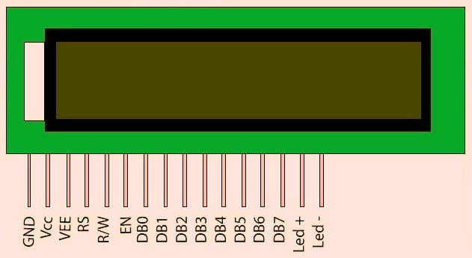](https://electrosome.com/wp-content/uploads/2013/07/16x2-LCD-Pin-Diagram.jpg)

Fig 4.3 LCD Display

**FEATURES**

• 5 x 8 dots with cursor

• Built-in controller (KS 0066 or Equivalent)

• + 5V power supply (Also available for + 3V)

• 1/16 duty cycle

• B/L to be driven by pin 1, pin 2 or pin 15, pin 16 or A.K (LED)

• N.V. optional for + 3V power supply

**Serial Interface:**

The PIC 16F877 having one serial port. It is interface with Max 232 IC with the help of TXD & RXD data pins, with the help of this signals we can send the serial data to GSM mode, i.e SIM800 use for sending the SMS.

**Output Relay Board:**

At the output of microcontroller, the ULN 2003 Relay driver IC is used.It amplifies the current and increase the driving capacity of the controller. At the output relay bank is interfaced. Through the relay contacts, we can control the gate, signal on the bridge and the also the audio hooter.

**4.5 GSM**

GSM (Global System For Mobile Communication ) is the world’s first cellular system to specify digital; modulation and network level architectures and services. It is a narrow band and TDMA digital transmission technique. GSM is a second generation cellular system standard that was developed to solve the fragmentation problem of the first cellular system of EUROPE.

FEATURES OF GSM:-

* Good subjective speech quality.
* Message Security.
* Max. Flexibility to provide services that are compatible with ISDN.
* High data rate transfer, short bursts, slow frequency hopping.
* Open-Network architecture.
* Use of the SIM (Subscriber Identity Mobile).

**Chapter 5**

**Project flow**

**5.1 POWER SUPPLY**

Power supply is the first and the most important part of our project. For our project we require +5v regulated power supply with maximum current rating 500 ma. The entire system work on DC power supply .

Following basic building blocks are required to generate power supply.

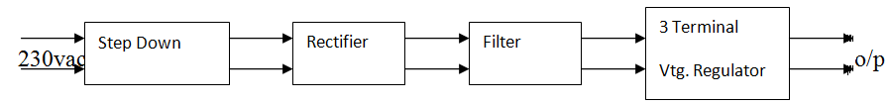 Fig 5.1 Power Supply

**Step down transformer**

Step down transformer is the first part or regulated power supply . To step down the mains 230V A.C. we require step down transformer. Following are the main characteristic of electronic transformer.

* Power transformer are usually designed to operate from source of low impedance at a single freq.
* It is required to construct with sufficient insulation of necessary dielectric strength.
* Transformer rating are expressed in volt-amp. The volt-amp of each secondary winding or windings is added for the total secondary VA. To this are added the load losses.
* Temperature rise of a transformer is decided on two well known factors i.e. losses on transformer and heat dissipating or cooling facility provided unit.

**5.2 Rectifier unit**

Rectifier unit is a circuit. Which converts A.C. into pulsating D.C. Generally semi-conducting diode is used as rectifying element due to its property of conducting current in one direction only generally there are two types of rectifier.

* Half wave rectifier
* Full wave rectifier.

In half wave rectifier only half cycle of mains A.C. rectified so its efficiency is very poor. So we use full wave bridge type rectifier, in which four diodes are used. In each half cycle, two diodes conduct at a time and we get maximum efficiency at o/p.

**5.3 Filter circuit**

Generally a rectifier is required to produce pure D.C. supply for using at various places in the electronic circuit, However, the o/p of rectifier has pulsating character i.e. if such a D.C. is applied to electronic circuit it will produce a hum i.e. it will contain A.C. and D.C. components. The A.C. components are undesirable and must be kept away from the load. To do so a filter circuit is used which removes (or filter out) the A.C. components reaching the load. Obviously a filter circuit is installed between rectifier and voltage regulator. In our project we use capacitor filter because of his low cost, small size and litile weight and good characteristic. Capacitors are connected in parallel to the rectifier o/p because it passes A.C. but does not pass D.C. at all.

**Three terminal voltage regulators**

A voltage regulator is a circuit. That supplies constant voltage regardless of change in load current. IC voltage regulators are versatile and relatively cheaper. The 7800 series consists of three terminal positive voltage regulators. These ICs are designed as fixed voltage regulator and with adequate heat sink, can deliver o/p current in excess of 1A. These devices do not require external component. This IC also has internal thermal overload protection and internal short circuit and current limiting protection for our project we use 7805 voltage regulator IC.

Fig 5.2 Design to step down transformer

7812

The following information must be available to the designer before the commences for the design of transformer.

1. Power output
2. operating voltage.
3. Frequency Range
4. Efficiency and Regulation

Size of core :

Size of core is one of the first considerations in regard of core and winding configuration used. Generally following formula is used to find area or size of core.

Ai = (p1/0.87)

Where

Ai = Area of cross section in sq. cm.

P1 = Primary voltage

In Transformer P1 = P2

For our project we required +5V regulated output. So transformer secondary rating is 12V, 500 mA.

So secondary power wattage is,

P2 = 12 X 500 X 10 –3 w = 6w.

so ,

Ai = (6/0.87)

=2.62

Generally 10% of area should be added to core accommodate all turns for low Iron losses and compact size.

So, Ai = 2.88.

Turns per volt

Turns per volt of transformer are given by relation

10,000

Turns/volt = -------------------

4.44f B Ai

Here;

F is the frequency in Hz

B is flux density in Wb/m2

A is net area of cross section.

For project for 50Hz the turns per volt for 0.91 wb/m2,

Turns per volt = 50/AiHHHHHHHHHHhhhh

= 50/ 2.88

= 17

Thus for primary winding = 220 X 17 = 3800.

For secondary winding = 12 X 17 = 204

**Rectifier design**

R. M. S. Secondary voltage at secondary of transformer is 12V. So, maximum voltage Vm across Secondary is

= RMS voltage *1.41

= 12* 1.41

=16.97

D.C. output voltage at rectifier o/p is

Vdc = 2Vm/3.14

= 2*16.97/3.14

= 10.80 v

PIV = 2 Vm

= 2 X 16.97

= 34V

Design of filter capacitor

Formula for calculating filter capacitor is,

1

C = -----------------------------

4. 3 r f RL

r = ripple present at o/p of rectifier.

(Which is maximum 0.1 for full wave rectifier?)

f = Frequency of mains A.C.

R = I/p impedance of voltage regulator IC.

1

C = ------------------- = 1000F

4 3 0.1*50*28

IC 7805 (Voltage regulator IC):-

**5.3 Specifications**

* Available o/p D.C.voltage = + 5V
* Line regulation = 0.03
* Load regulation = 0.5
* Vin maximum = 35 V
* Ripple Rejection = 66-180(db)

**5.4 Circuit Diagram**

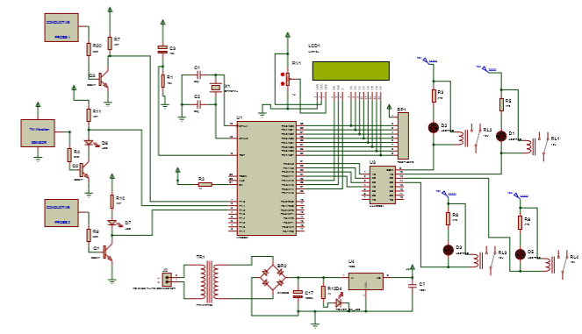

Fig.5.2 Circuit Diagram

**5.5 Power Supply:**



# **5.6 PCB DESIGNING:**

* After selection of electronic circuit, make a block diagram of various circuits to know various inter-connections required, which will help in reducing the number of wires.
* The designer should have the complete idea of the circuit regarding the function and signal flows through.
* Keep each and every component you need, while starting the designing.
* Use of templates is essential if you are new designer, if the design is manual i.e. handmade and not with software such as Orcas, Auto CAD, Pads, Ideas, Circuit maker, etc.
* Standard PCB size should be decided in the beginning only.
* Preferably, layout and artwork should be in 1:2 scales.
* Sequential stage after PCB size is decided.
* Component placement.
* Track routing i.e. layout.
* Artwork making with ink or readymade tapes and pads.
* While routing the tracks, carrying AC mains voltage, consider the safety rules and regulations.
* In analog and digital systems together, care should be taken that analog and digital ground will not mix each other affecting the stability and fluctuations in the display.
* In power system i.e. high current, the track width and the track spacing should be as maximum as possible.
* While placing the components on the PCB preferably the load on PCB, should be evenly distributed to avoid the problems at completion stage during wave-soldering i.e. warping of PCB etc.
* To avoid weakening of the pup tool, the perforation length should be kept minimum i.e. <40 mm.
* For the manually shouldered components vent i.e. cut pads should be provided to avoid the blocking of the holes during shouldering.

**5.7 Layout of Project:**

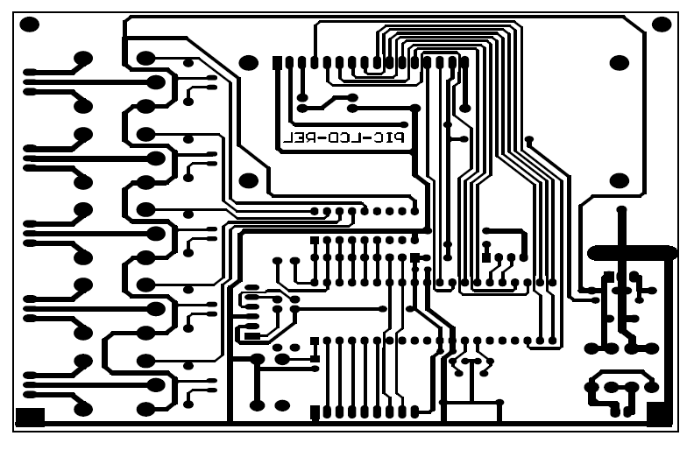**Fig.5.7 PCB Layout**

**5.8 Preparation steps:**

### Searching of project

1. Finalization project
2. Block diagram and synopsis preparation
3. Hardware design
4. Component procurement
5. PCB development
6. PCB assembly
7. Software scheme
8. Code development
9. Trials
10. Final testing
11. Result preparation
12. Documentation

**5.9ARTWORK:**

**Artwork:**

The generation of PCB artwork should be considered as the first step of PCB manufacturing process. The importance of a perfect artwork should not be underestimated. Problems like inaccurate registration, broken annular rings or too critical spacing are often due to bad artwork. And even with the most sophisticated PCB production facilities, PCB can be made better than the quality of artwork used.

**Screen Printing:**

The process of screen printing is well known to he printing industry because of its inherent capabilities of printing a wide range of link on almost any kind of surface including glass, metal, plastic fabrics, wooer etc, found their way in to an extremely broad field of applications. Screen printing offers the advantages of wide control on the ink deposition, thickness though the selection of suitable mass density and composition in the production of PCB’s.

**Etching:**

In all subtractive PCB process, etching is one of the most important steps. The final copper pattern is formed by selective removal of the unwanted copper, which is not protected by an etching unit. Solutions, which are used in etching process, are known as enchants.

* Ferric chloride
* Cupric chloride
* Chromic Acid
* Alkaline Ammonia

Of these Ferric Chloride is widely used because it has short etching time and it can be stored for a long time. Etching of PCB’s as required in modern electronic equipment production, is usually done in spray type etching machines. Tank or Bubble Etching, in which the boards kept in a tank were lowered and fully immersed in to the agitated, has almost disappeared.

**Component Mounting:**

Careful mounting of components on PCB increases the reliability of assembly:-Leads must be cleaned before they are inserted in the PCB holes. Asymmetric lead bending must be avoided. The ENT lead must fit in to holes properly so that they can be soldered. When the space is to be saved then vertical mounting is preferred. The vertical lead must have an insulating sleeve.

**Soldering:**

The next process after the component mounting is soldering; solder pint is achieved by heating the solder and base metal about the melting point of the solders is used.

The necessary heat depends upon:

* + - The nature and type of joints
    - Melting temperature of solder
    - Flux

**ASSEMBLY OF THE CIRCUIT**

**Component placement**

1. Preferably, place the component in X-Y direction subjected to mechanical construction.
2. All components should be flat mounted i.e. flat placed to avoid of leads and for easy requirements. However in case of space limitation the components such as resistors, diodes, etc. may be mounted vertically which doesn’t affect the performance.
3. In case separate analog and digital ground.
4. Orientation of multi-lead components(e.g. switches, Ics) should be connected in between the analog and digital ground .
5. Sufficient clearance is provided around component so that inversion or replacement ands repair is easy.
6. The design should such that minimum jumpers are allowed.
7. It is preferable that, components like present, coils, and trim pots, etc. which alignment of calibration are placed in such that, they are accessible after the assembly of the PCB on cabinet also.
8. If the components are not flush mounted, provide the sleeve for leads.

**Chapter 6**

**Software Used**

**6.1 ALGORITHM:**

Step1: Start

Step2: Initalise Microcontroller

Step3: CLR all output port

Step4: Initalise LCD

Step5: Display welcome Message

Setp6: Read input port

Step7: Is S1=1

Step8: Set output port

Step9: Relay1,2&3 ON

Step10: Hooter ON, Gate close & Signal ON

Step11: Initalise port

Step12: Initalise SBUF

Step13: ACK GSM

Step14: Send SMS

Step15: Read I/O port

Setp16: Is ACK=0

Step17: CLR Hooter RL2

Step18: Repeate

Step19:END

**6.1 Flowchart**

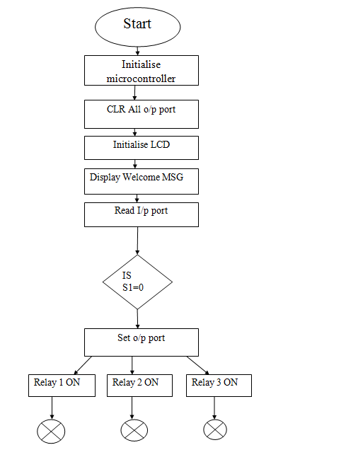

# 

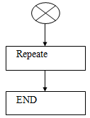

**Fig6.1 Flowchart**

# **Chapter 7**

**Performance Evaluation**

**7.1 TESTING**

Testing is a set of activities that can be planned in advance and conducted systematically. A number of testing strategies have been proposed in literature all provide the software developer with a template for testing and have the following generic characteristics.

* Testing begins at the component level and works outward towards integration of the entire computer based system.
* Testing is conducted by the developer of the software and for large projects a independent test group may be used.
* Testing and debugging are different activities but debugging must be accommodated in any testing strategy.

**Strategic Issues**

The following are the strategic issues that must be addressed if a successful software testing strategy is to be implemented.

* Specify product requirements in a quantifiable manner long before testing commences.
* State testing objectives explicitly.
* Understand the needs of the users and develop a profile for each category of users.
* Build robust software that incorporates certain techniques to enable it to test itself.
* Use effective formal technical reviews as a filter prior to testing.
* Conduct formal technical reviews to access the test strategy and test case themselves.
* Develop a continuous improvement approach for the testing process.

Software Testing is a critical element of software quality assurance and represents the ultimate reviews of specification, design and coding. Testing present an interesting anomaly for the software. Testing is vital to the success of the system. Errors can be injected at any stage during development. System Testing makes a logical assumption that if all the parts of the system are correct, the goal will be successfully achieved. During testing, the program to be tested is executed with set of data and the output of the program for the test data is evaluated to determine if the programs are performing as expected. A series of testing are

performed for the proposed system before the system is ready for user acceptance testing. The testing steps are:

* Unit Testing
* System Testing
* Integration Testing
* Acceptance Testing

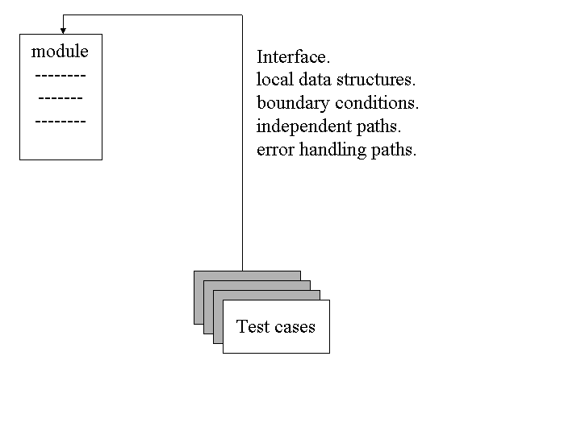

Fig 7.1 unit testing

**7.2 Testing & Troubelshooting**

**Before soldering in components:**

* Check that component agree with the parts list (value and power of resistors, value and voltage rating of capacitor, etc.) if in any doubt double check the polarized components (diodes, capacitor, rectifiers etc)
* If there is a significant time elapse between circuit, take the trouble to read the article; the information is often given in a very condensed from. Try to get most important point out of the description of the operation of the circuit, even if you don’t understand exactly what is supposed to happen.
* If there is any doubt that some component may not be exact equivalent, check that they are compatible.
* Only use good quality IC sockets.
* Check the continuity of the tracks on the PCB (and through plated holes with double sided boards) with a resistance meter or continuity tester.
* Make sure that all drilling, filling and other ‘heavy’ work is done before mounting any components.
* If possible keep any heat sinks well isolated from other components.
* Make a wiring diagram if the layout involves lots of wires spread out in all directions.
* Check that the connectors used are compatible and that they are mounted the right way round.
* Do not reuse wire unless it is of good quality. Cut off the ends and strip it a new.

**After mounting the component:**

* Inspect all soldered joints by eye or using a magnifying glass and check them with a continuity tester. Make sure there are no dry joints and no tracks are short circuited by poor soldering.
* Ensure that the positions of all the component agree with the mounting diagram
* Check that any links needed are present and that they are in the right positions to give the desired configuration.
* Check all ICs in their sockets (see that there are no pins bent under any ICs, no near ICs are interchanged etc.)
* Check all the polarized components (diodes, capacitor etc) are fitted correctly.
* Check the wiring (watch for off cuts of components leads) at the same time ensure that there are no short-circuits between potentiometer, switches, etc. and there immediate surrounding (other components or the case). Do the same with mounting hardware such as spacers, nuts and bolts etc.
* Ensure that the supply transformer is located as closely as possible to the circuits (this could have a significant improvement in the case of critical signal level).
* Check that the connections to the earth are there and that they are of good contact.
* Make sure the circuit is working correctly before spending any time putting it into a case.

**And if it breaks down:**

* Recheck everything suggested so far.
* Re-read the article carefully and carefully anything about which you are doubtful.
* Check the supply voltage or voltages carefully and make sure that they reach the appropriate components especially pins of the ICs (test the pins of ICs and not the soldered joints).
* Check currents (generally they are stated on the circuit diagram or in the text). Don’t be too quick to suspect the ICs of overheating.
* If possible check the operation of the circuit in the separate stages as a general rule follow the course of the signal.
* While checking voltages, currents, frequencies or testing the circuits with an oscilloscope work systematically and take notes.

**Chapter 8**

**Conclusion**

**8.1 Conclusion:**

A multi functional wireless bridge safety system has been developed for concurrent deployment of sensors. The sensing capabilities satisfies the immediate requirement for economic,low maintenance load ratings and short term dyanamic measurements in addition to providing the hardware functionality for development of a long term continuous bridge safety.

Bridges are assets to mankind and have to last for generation as the constructions of bridge influences the whole whole ecosystem and the change is permant.so proper planning to adopt the bridge into the natural ecosystem has to be done.

* 1. **Advantages:**
* It decreases overall cost of installation.
* It reduces huge complication because of wireless connection.
* Current system use easy and low cost wired network amongst sensors in the bridge.
* It avoids the major accidents.

**8.3 Application:**

* It is used in all over world for any types of bridges.
* It can avoid accidents caused by extream weather condtions.
* It is used for monitoring the faults of bridges occurred.
* The wireless sensor system enables remote damage detection.

**8.4 References:**

* Chae, M.J.Ph.D, P.E.Kim, Yoo H.S.J.R. Cho,M.Y, Ph. D.”Bridge condition monitoring system using wireless network (cdma and zigbee)”.
* Matthew J. Whelan, Michael P. Fuchs, Michael V. Gangone, Clarkson University, Development of a wireless bridge monitoring system for condition assessment Using hybrid techniques.
* K.Fathima, K.Shanmugavalli, International Journal of Emerging Science and Engineering (IJESE), Dec2013
* G. Lederman, Z. Wang, J. Bielak, H. Noh, J. H. Garrett, S. Chen, J. Kovaèeviæ, F. Cerda, and P.Rizzo, "Damage quantification and localization algorithms for indirect SHM of bridges.
* S. Chen, A. Sandryhaila, J.M.F. Moura and J. Kovačević, "Adaptive Graph Filtering:Multiresolution Classification on Graphs" Proc. IEEE Glob. Conf. Signal Information Processing, Austin, TX, Dec. 2013 [

**Chapter:9**

**Project photo**